Lab Manual: Mobile Computing Lab (CSL-603) Branch: Computer Engg. Sem: VI Year: FH 2025
Experiment No 3: GSM Security
PART A
(PART A: TO BE REFFERED BY STUDENTS)
A.1 Aim: To implement GSM security algorithms (A3/A5/A8)
A.2 Objectives: To understand the security algorithms in mobile networks
A.3 Outcomes: Student will be able to implement security algorithms for mobile communication network. (LO-4)
A.4 Tools Used/programming language: Java, Python etc A.5 Theory:
• Authentication verifies identity and validity of SIM card to the network and ensures that subscriber has access to the network.
• Term used
✔ Ki= individual subscriber authentication key, it is 32 bit number and present only in SIM card and stored in authentication center.
✔ RAND= random 128 bit number generated by AUC (authentication center) when network request to authenticate the subscribers.
✔ SRES (signed responses) = 32 bit crypto variable used in authentication process.

Lab Manual: Mobile Computing Lab (CSL-603) Branch: Computer Engg. Sem: VI Year: FH 2025
✔ Kc = 64 bit cipher key.
• MS is challenged by given RAND by the network.
▪ Security in GSM
• Three algorithms have been specified to provide security services in GSM. Algorithm A3 is used for authentication, A5 for encryption, and A8 for the generation of a cipher key.
• In the GSM standard only algorithm A5 was publicly available, whereas A3 and A8 were secret, but standardized with open interfaces.
• Network providers can use stronger algorithms for authentication– or users can apply stronger end-to-end encryption.
• Algorithms A3 and A8 (or their replacements) are located on the SIM and in the AUC and can be proprietary.
• Only A5 which is implemented in the devices has to be identical for all providers.
Subscriber Authentication
For subscriber authentication algorithm used is A3
1. A3 algorithm is inbuilt inside SIM and AUC, Input for A3 is Ki and RAND
2. Ki=Stored inside SIM(kiis encrypted inside SIM card) and not share on network and also present in AUC of MSC.
3. Before a subscriber can use any service from the GSM network, he or she must be authenticated. Authentication is based on the SIM, which stores the individual authentication key Ki, the user identification IMSI, and the algorithm used for
authentication A3.
4. When user want to access GSM network IMSI number from SIM send to MSC then HLR then to AUC.
5. Now AUC check IMSI number is present or not and identify associated Ki value (Ki is fixed), in this procedure AUC generate RAND number which is different for every new user request.

6. AUC using authentication algorithm A3(input to A3 are ki and RAND) calculate SRES as output of A3 and AUC using algorithm A8 of cipher generation (input to
A8 are ki and RAND) calculate Kcand send these SRES, Kc and RAND to HLR
then from HLR to MSC. These three terms SRES, Kc and RAND are called as triplet.
7. MSC now send only RAND value to MS
8. MS using algorithm A3 (input to A3 is Ki and RAND)calculate SRES and using algorithm A8 calculate Kc and send these SRES and kc to MSC
9. MSC check SRES receive from MS and Network are same or not. If both are same
user is authenticated and connection is set up.
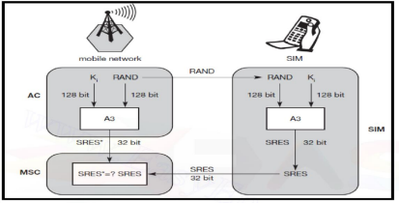Figure: Subscriber Authentication
Encryption
1. To ensure privacy, all messages containing user-related information are encrypted in GSM over the air interface.
2. After authentication, MS and BSS can start using encryption by applying the cipher key Kc
3. Kc is generated using the individual key Ki and a random value by applying the algorithm A8. Note that the SIM in the MS and the network both calculate the same Kc based on the random value RAND. The key Kc itself is not
transmitted over the air interface.

4. MS and BTS can now encrypt and decrypt data using the algorithm A5andthe cipher key Kc. As Figure shows, Kc should be a 64 bit key – which is not very strong, but is at least a good protection against simple eavesdropping. However, the publication of A3 and A8 on the internet showed that in certain implementations 10 of the 64 bits are always set to 0, so that the real length of the key is thus only 54 consequently, the encryption is much weaker.
5. Note: An eavesdropping attack, also known as a sniffing or snooping attack, is a theft of information as it is transmitted over a network by a computer, smart phone, or another connected device. The attack takes advantage of unsecured network communications to access data as it is being sent or received by its user. Eavesdropping is the act of intercepting communications between two points.
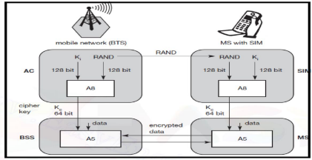Figure: Data Encryption
A.6 Sample Source Code:
https://www.theprogrammingcodeswarehouse.com/2020/04/implementation ofa3-security.html

import random
k=random.getrandbits(128)
m=random.getrandbits(128) kb=bin(k)[2:]
mb=bin(m)[2:] kbl=kb[0:64] kbr=kb[64:]
mbl=mb[0:64] mbr=mb[64:]
a1=int(kbl,2)^int(mbr,2)
a2=int(kbr,2)^int(mbl,2) a3=a1^a2
a4=bin(a3)[2:].zfill(64) a5=a4[0:32]
a6=a4[32:] a7=int(a5,2)^int(a6,2)
print("128 Bit Key = ",kb)
print("128 Random Bits Generated = ",mb) print("RES/SRES
= ",bin(a7)[2:].zfill(len(a5)))
A.6 Sample Output:
128 Bit Key
=1111101110100110010000010010011000100111001111010011101011010001111000111000001 111
011101110110111010100010110101000111010001
128 Random Bits Generated
=1100000100010001011000101110010011011010110011001000110101110001001000010100101 001
0000010011110000001000011001001111111000100
RES/SRES=11110110110100000010111110001101

PART B
Lab Manual: Mobile Computing Lab (CSL-603) Branch: Computer Engg. Sem: VI Year: FH 2025
(PART B: TO BE COMPLETED BY STUDENTS)
(Students must submit the soft copy as per following segments within two hours of the practical. The soft copy must be uploaded on the ERP or emailed to the concerned lab in charge faculties at the end of the practical in case the there is no ERP access available)
Roll No. C-56 | Name: Quazi Md Moinuddin
Class : TE COMPS C | Batch : C-1
Date of Experiment:27.01.25 | Date of Submission :5.02.25
Grade :

B.1 Question of Curiosity:
Q.1: Source Code (students need to implement GSM Security Algorithm using any programming language like Java, Python, etc)
import random

# Generate a random 128-bit key and a random 128-bit number
k = random.getrandbits(128)
m = random.getrandbits(128)

# Convert the numbers to binary strings
kb = bin(k)[2:].zfill(128) # Ensure the key is 128 bits
mb = bin(m)[2:].zfill(128) # Ensure the random bits are 128 bits

# Split both the key and the random bits into two 64-bit halves
kbl = kb[0:64] # Left half of the key
kbr = kb[64:] # Right half of the key
mbl = mb[0:64] # Left half of the random bits
mbr = mb[64:] # Right half of the random bits

# XOR operation on the corresponding halves
a1 = int(kbl, 2) ^ int(mbr, 2) # XOR left half of key with right half of random bits
a2 = int(kbr, 2) ^ int(mbl, 2) # XOR right half of key with left half of random bits

# XOR the results of the previous two XORs to get the final result
a3 = a1 ^ a2

# Convert the final result to a 64-bit binary string
a4 = bin(a3)[2:].zfill(64)

# Split the result into two 32-bit parts
a5 = a4[0:32] # Left part of the final result
a6 = a4[32:] # Right part of the final result

# XOR the two 32-bit parts
a7 = int(a5, 2) ^ int(a6, 2)

# Output the results
print("128 Bit Key = ", kb)
print("128 Random Bits Generated = ", mb)
print("RES/SRES = ", bin(a7)[2:].zfill(len(a5))) # Print the final result in binary

Q.2: Output of GSM Security Algorithm
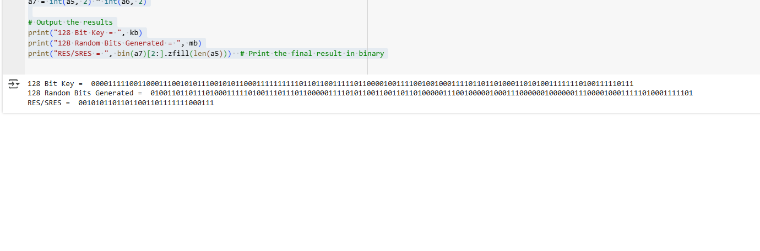

Q.3: List out various elements of GSM architecture and explain in brief function of each element.
Mobile Station (MS): The mobile device (phone) used by the subscriber. It includes the SIM card that stores subscriber information.
Base Station Subsystem (BSS): Manages radio communication between mobile devices and the network.
- Base Transceiver Station (BTS): Handles radio transmission.
- Base Station Controller (BSC): Manages multiple BTS units and controls handovers.
Network and Switching Subsystem (NSS): Manages call routing, switching, and communication across the network.
- Mobile Switching Center (MSC): Routes calls and data.
- Visitor Location Register (VLR): Stores temporary information for roaming users.
- Home Location Register (HLR): Central database for subscriber details.
- Authentication Center (AUC): Ensures security and user authentication.
- Gateway MSC (GMSC): Routes calls outside the GSM network.
Operation and Support Subsystem (OSS): Monitors and manages the network’s performance and maintenance.
Short Message Service Center (SMSC): Manages SMS (text message) delivery and storage.
Gateway GPRS Support Node (GGSN): Connects the GSM network to external data networks (like the internet).
Serving GPRS Support Node (SGSN): Manages the delivery of data packets for GPRS and EDGE services.

B.2 Conclusion:
In this experiment I have successfully understand GSM security algorithm and also successfully implemented it using python program.

